# Project Report: Network Security Suite

## Introduction:

Network security is one of the most important areas in the cybersecurity domain. Every device connected to a network is vulnerable to attacks, data leaks, and intrusions if not properly monitored and protected.

The **Network Security Suite** is a project that aims to:

* Provide **basic security protection** through simple tools like a firewall and packet sniffer.
* Allow the user to **monitor the network traffic in real-time** using a GUI.
* Help users understand what kind of data is passing through their network and log it for future analysis.
* Provide **alerts** when suspicious activities happen.

This project is specially designed to give users an easy-to-use interface to manage basic network security without needing advanced knowledge.

## Objective:

The **main goal** of this project is to provide **basic network security tools** in one simple software package that anyone can use.

**✅** Detailed Objectives:

1. **User-Friendly Security Suite**
   * The project should be easy to use even for beginners.
   * The GUI should help users navigate the tools without typing complex commands.
2. **Real-Time Monitoring and Alerts**
   * The system should capture packets and detect suspicious activity as it happens.
   * It should notify the user immediately when an intrusion or anomaly is found.
3. **Essential Security Tools in One App**
   * The suite should combine important tools like:
     + Packet Sniffer
     + Basic Firewall
     + Log Analyzer
     + Real-Time Alerts
4. **Log Management**
   * The system should create log files for:
     + Packet activity
     + Firewall events
     + Intrusions
   * These logs can be reviewed later to understand security events.

## Tools and Technologies Used

The **Network Security Suite** is built using simple but powerful technologies that make the project lightweight and easy to run.

**✅** Tools Table:

| **Tool** | **Purpose** |
| --- | --- |
| **Python** | Core language used to build the project. |
| **Tkinter** | Used to create the Graphical User Interface (GUI). |
| **Scapy / OS Libraries** | Used for packet sniffing and network operations. |
| **HTML (Templates)** | Used to display logs in a clean format through a basic web interface. |

## Explanation of Each Tool**:**

### 1. Python

* The backbone of the project.
* Handles the logic for packet sniffing, firewall rules, alerts, and file management.
* Python’s simplicity makes the project readable and easy to maintain.

### 2. Tkinter

* Python’s built-in GUI library.
* Used to design simple windows, buttons, labels, and forms for the project.
* Makes the project more user-friendly without needing command-line knowledge.

### 3. Scapy / OS Libraries

* Handles low-level network tasks like packet capturing and firewall control.
* Can sniff incoming and outgoing packets for real-time analysis.

### 4. HTML (Templates)

* Used for displaying log files in a readable format inside a browser window.
* Clean and easy log presentation.

## Modules Description

The **Network Security Suite** is made of multiple small modules (Python files). Each module has a specific function in the project.

### a. Packet Sniffer (sniffer.py)

* Captures **real-time packets** from the network.
* Can analyze and display:
  + Source IP
  + Destination IP
  + Protocol type
* Helps monitor what type of traffic is flowing through the network.

### b. Basic Firewall (basic firewall.py and firewall.py)

* Implements **simple blocking rules.**
* Can filter out unwanted packets.
* Protects the system from suspicious IP addresses or blocked protocols.
* Does **not** work like an advanced firewall but provides a starting level of defence.

### c. Real-Time Alerts (alerts.py)

* Sends **instant alerts** to the user when something unusual is detected.
* Alerts can be based on:
  + Specific packet patterns.
  + Blocked IP detection.
  + Suspicious packet counts.

### d. Log Management (logs folder)

* **Logs all activities:**
  + Packets captured.
  + Firewall actions.
  + Intrusion attempts.
* Helps the user review what happened on the network at any time.

### e. Log Analyzer (log_analyzer.py)

* Reads log files and presents the important data.
* Makes it easier to understand the security status without manually checking each log file.

### f. GUI (gui.py and main.py)

* Provides a **user-friendly interface** to:
  + Start/Stop sniffing.
  + View logs.
  + Manage firewall settings.
* main.py acts as the **project entry point.**

## System Requirements

The **Network Security Suite** is a lightweight project that can run on most basic systems without heavy hardware.

**✅** Minimum Requirements

| **Component** | **Requirement** |
| --- | --- |
| **Operating System** | Windows / Linux |
| **Python Version** | Python 3.x (Recommended: Python 3.8 or above) |
| **RAM** | Minimum 4 GB |
| **Disk Space** | Less than 100 MB |
| **Software** | Python and pip should be installed |

## Explanation:

* OS Support:  
  The project is designed to run on both Windows and Linux machines as it uses cross-platform Python libraries.
* Python Version:  
  Python 3.x is required because it supports the latest features and libraries like Tkinter and Scapy.  
  Python 2 is not supported.
* RAM:  
  Minimum 4GB is enough since the packet sniffing and GUI are not resource-heavy.
* Disk Space:  
  Very low storage is needed as this is a small-scale Python project.
* Additional Software:  
  Make sure that Python and pip are properly installed to run and install the project dependencies.

## Output Screenshots:

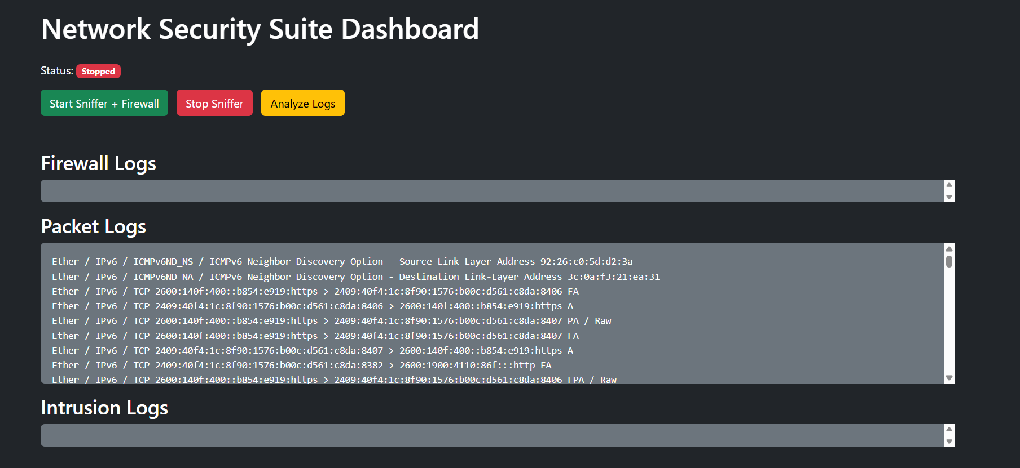

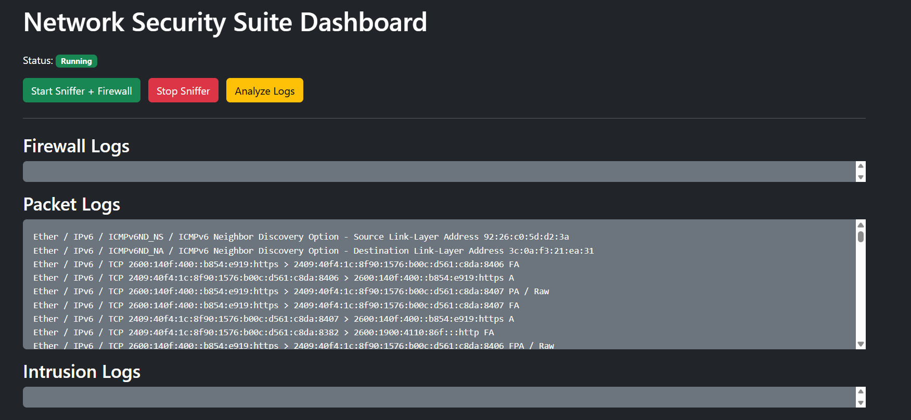

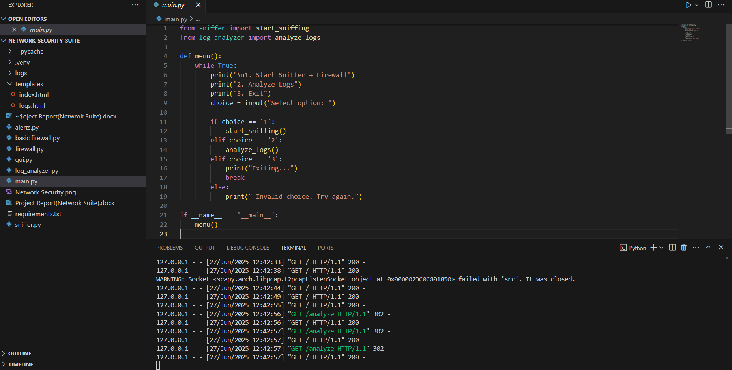

## Advantages

The **Network Security Suite** offers several benefits that make it a useful project, especially for beginners and small network setups.

### 1. Simple to Use

* The project is designed with an easy-to-understand GUI.
* Even users with basic knowledge can use the security suite without typing complex commands.

### 2. GUI-Based Navigation

* The entire system is controlled through **buttons, windows, and menus**.
* No command-line interface is needed, making it user-friendly.

### 3. Real-Time Alerts

* Provides **instant warnings** when a suspicious packet or event is detected.
* Helps the user react quickly to potential network threats.

### 4. Log Management

* The suite automatically creates and stores log files.
* These logs help in:
  + Tracking network activity.
  + Reviewing past security events.
* Makes it easier for future security analysis.

### 5. Educational Tool

* Perfect for students and beginners to **learn basic network security concepts** like sniffing, firewalling, and log analysis.
* Can be used for demonstration in labs or workshops.

## Advantages

The **Network Security Suite** offers several benefits that make it a useful project, especially for beginners and small network setups.

### 1. Simple to Use

* The project is designed with an easy-to-understand GUI.
* Even users with basic knowledge can use the security suite without typing complex commands.

### 2. GUI-Based Navigation

* The entire system is controlled through **buttons, windows, and menus**.
* No command-line interface is needed, making it user-friendly.

### 3. Real-Time Alerts

* Provides **instant warnings** when a suspicious packet or event is detected.
* Helps the user react quickly to potential network threats.

### 4. Log Management

* The suite automatically creates and stores log files.
* These logs help in:
  + Tracking network activity.
  + Reviewing past security events.
* Makes it easier for future security analysis.

### 5. Educational Tool

* Perfect for students and beginners to **learn basic network security concepts** like sniffing, firewalling, and log analysis.
* Can be used for demonstration in labs or workshops.

## Future Enhancements

To make the **Network Security Suite** more powerful, scalable, and closer to real-world security tools, several future improvements can be added.

### 1. Advanced Firewall with Custom Rules

* Allow users to:
  + Set custom blocking rules (IP ranges, specific ports, protocols).
  + Dynamically update firewall rules without restarting the program.
* Add **pattern-based filtering** to block known attack signatures automatically.

### 2. Real-Time Packet Visualization

* Develop **graphical dashboards** to show:
  + Live packet flows.
  + Network maps.
  + Traffic volume charts.
* Helps users quickly understand what’s happening on the network visually.

### 3. Multi-Threaded Sniffer and Log Processing

* Improve performance by:
  + Running packet capture and GUI in separate threads.
  + Processing large amounts of packet data without lagging the interface.

### 4. Cloud Log Storage and Remote Access

* Store logs in the cloud (Google Drive, AWS, etc.) to:
  + Access logs from anywhere.
  + Provide centralized monitoring for multiple systems.
* Implement **remote alert notifications via email, SMS, or mobile apps.**

### 5. Database-Driven Log Management

* Store logs in a structured **database like SQLite or MySQL.**
* Enable searching, filtering, and analyzing logs efficiently.

### 6. Integration with Security APIs

* Connect with external threat intelligence services.
* Automatically block IP addresses reported as malicious in real-time.

### 7. Cross-Platform Support

* Improve packet capturing to work seamlessly across **Windows, Linux, and macOS.**
* Create installer files (.exe or .deb) for easier setup.

### 8. User Authentication and Access Control

* Add login/logout features to prevent unauthorized users from accessing the suite.
* Provide **role-based access** if used in larger teams.

### 9. Automated Threat Detection (Optional Advanced)

* Integrate basic machine learning to:
  + Detect unusual network behaviour.
  + Predict potential attacks based on traffic patterns.

## Conclusion

**The Network Security Suite is a beginner-friendly, educational project that brings together essential network security functions in a simple, GUI-based application.  
It helps users understand and experiment with:**

* **Packet Sniffing**
* **Basic Firewall Setup**
* **Log Management**
* **Real-Time Alerts**

Key Takeaways:

* **The project provides an excellent foundation for learning network security concepts practically.**
* **It combines multiple security tools into one compact system that is easy to install and use.**
* **The real-time features allow users to see the impact of their security controls immediately.**
* **The project promotes awareness of how networks can be monitored and protected.**

## References:

The following resources were used as **guides, learning materials, and technical references** during the development of the **Network Security Suite** project:

## Technical References:

1. **Python Official Documentation**
   * Used for core Python functions, file handling, and module usage.
   * <https://docs.python.org/3/>
2. **Tkinter GUI Documentation**
   * Helped in designing the Graphical User Interface (GUI) for the project.
   * <https://docs.python.org/3/library/tkinter.html>
3. **Scapy Official Documentation**
   * Used as a reference for implementing packet sniffing and handling network packets.
   * <https://scapy.readthedocs.io/en/latest/>
4. **OS and Socket Libraries (Python Standard Library)**
   * Provided the basic support for file operations, system interactions, and network communications.

Learning Resources

1. **OWASP Security Guidelines**
   * Provided general knowledge on security best practices and common vulnerabilities.
   * <https://owasp.org/>
2. **TutorialsPoint Python GUI Guide**
   * Used for step-by-step Tkinter GUI design and Python setup.
   * https://www.tutorialspoint.com/python/python_gui_programming.htm
3. **YouTube Python Security Tutorials**
   * Practical demonstrations for setting up basic firewall and packet sniffing in Python.

### Project-Specific Inspirations

1. **GitHub Python Security Projects**
   * Referenced open-source projects to understand folder structures and best practices.